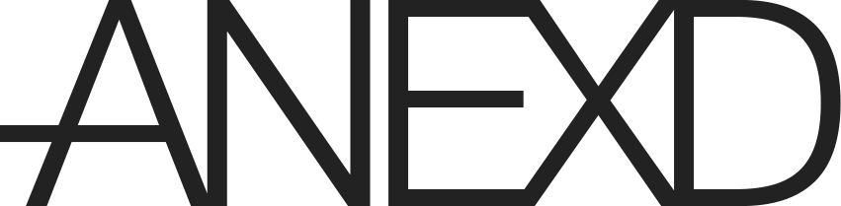

Harry Jones

Fred Barnes

CO600: Design document

30th March 2016

Frontend UX/UI Design Process

One of the key components of this project is its user interface; we’re producing a web application with a multitude of views for both desktop and mobile browsers. It’s essential we provide a beautiful and easy to use experience for our end users. To achieve this, ANEXD underwent a full design process, from user flow diagrams to high fidelity designs. This document explains the process we undertook to produce the ANEXD UI.

# User Flows

After we came to the conclusion that ANEXD would be our project, the first thing for the UX/UI was our user flow. These quick diagrams help to define which views we’ll need to produce and how they fit together.

## Desktop Flow

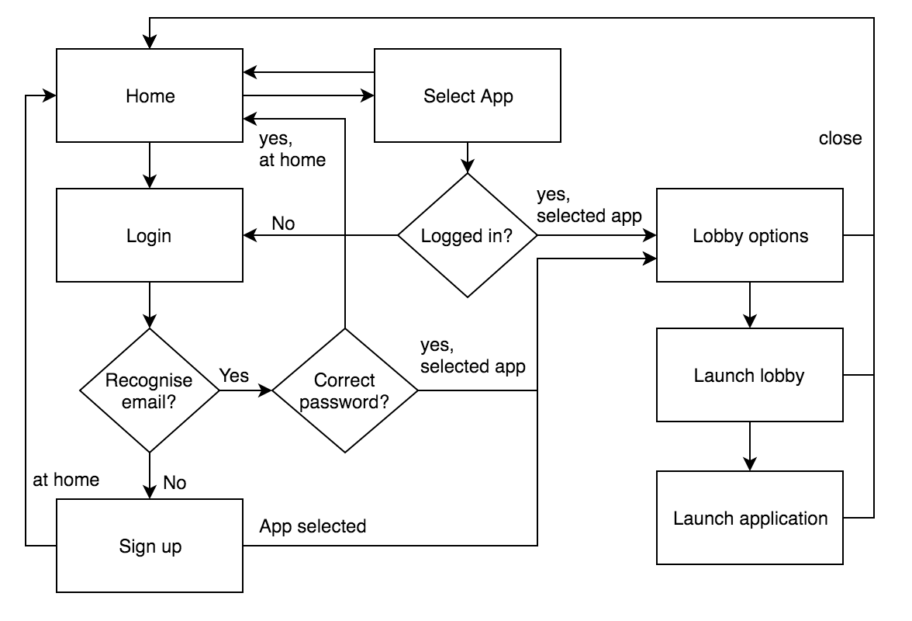

The desktop flow was considerably more complicated than that of the mobile as it has more options, more moving parts, and more interaction. Desktop users need functionality to log in and out, sign up, select applications, and launch lobbies. This diagram gave us a good idea of how the desktop was going to link together.

## Mobile Flow

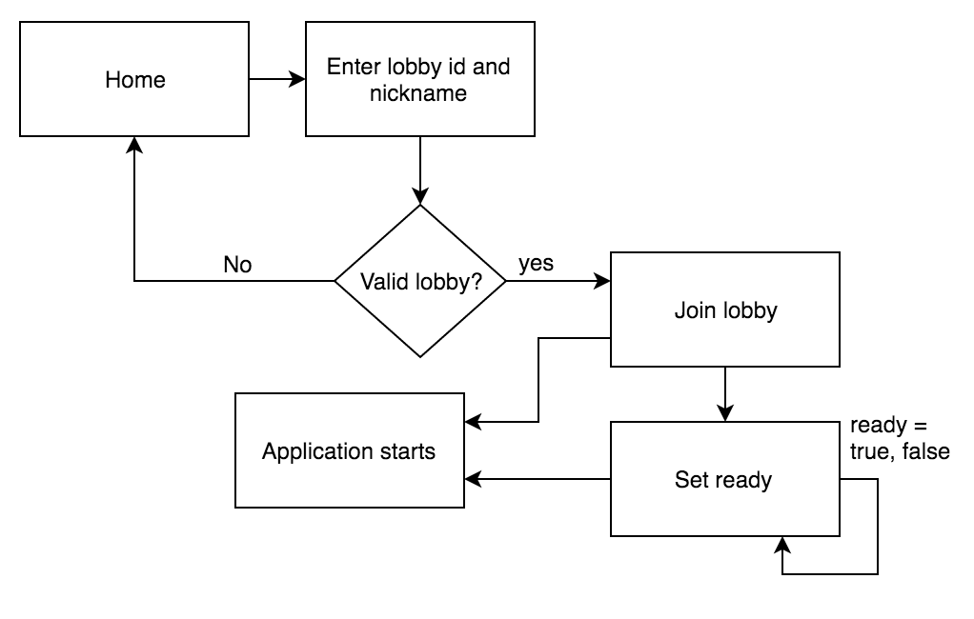

The mobile flow only needs a few different views. As all mobile users will be anonymous there’s no logging in or out or joining, simplifying the flow nicely.

# Storyboards

Next, we tackled the general designs for the screens. These were quick, frequently updated sketches that asked questions about where the various elements on the page would be, and how users would activate the transitions between each view.

## Desktop Storyboard

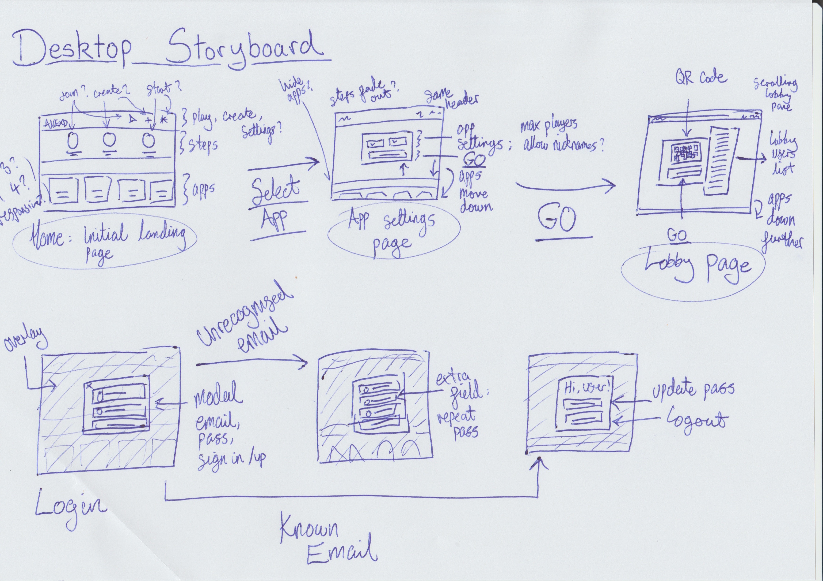

As the image above shows, we were experimenting with how to arrange the elements of the page, and when transitions between views would occur.

## Mobile Storyboard

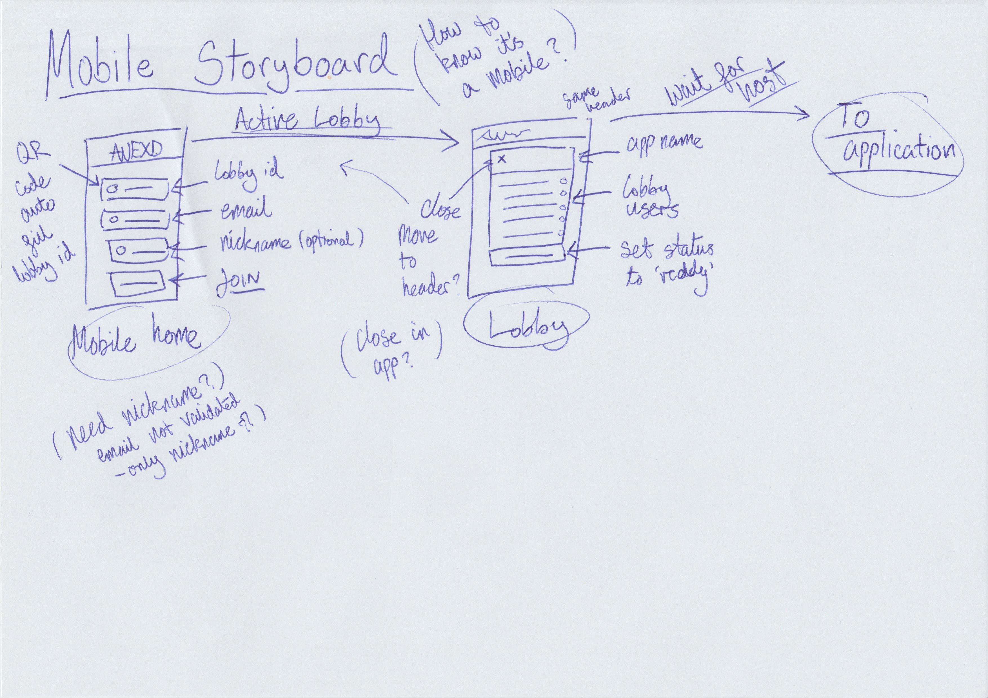

The mobile storyboard ended up only being two screens long; one for joining the lobby, and one for showing it.

# High Fidelity Designs

After mulling over the flows and storyboards – and producing many illegible scribbles – we began on the high fidelity designs, which were produced using Photoshop (Creative Cloud).

## Desktop Designs

## **Desktop Home**

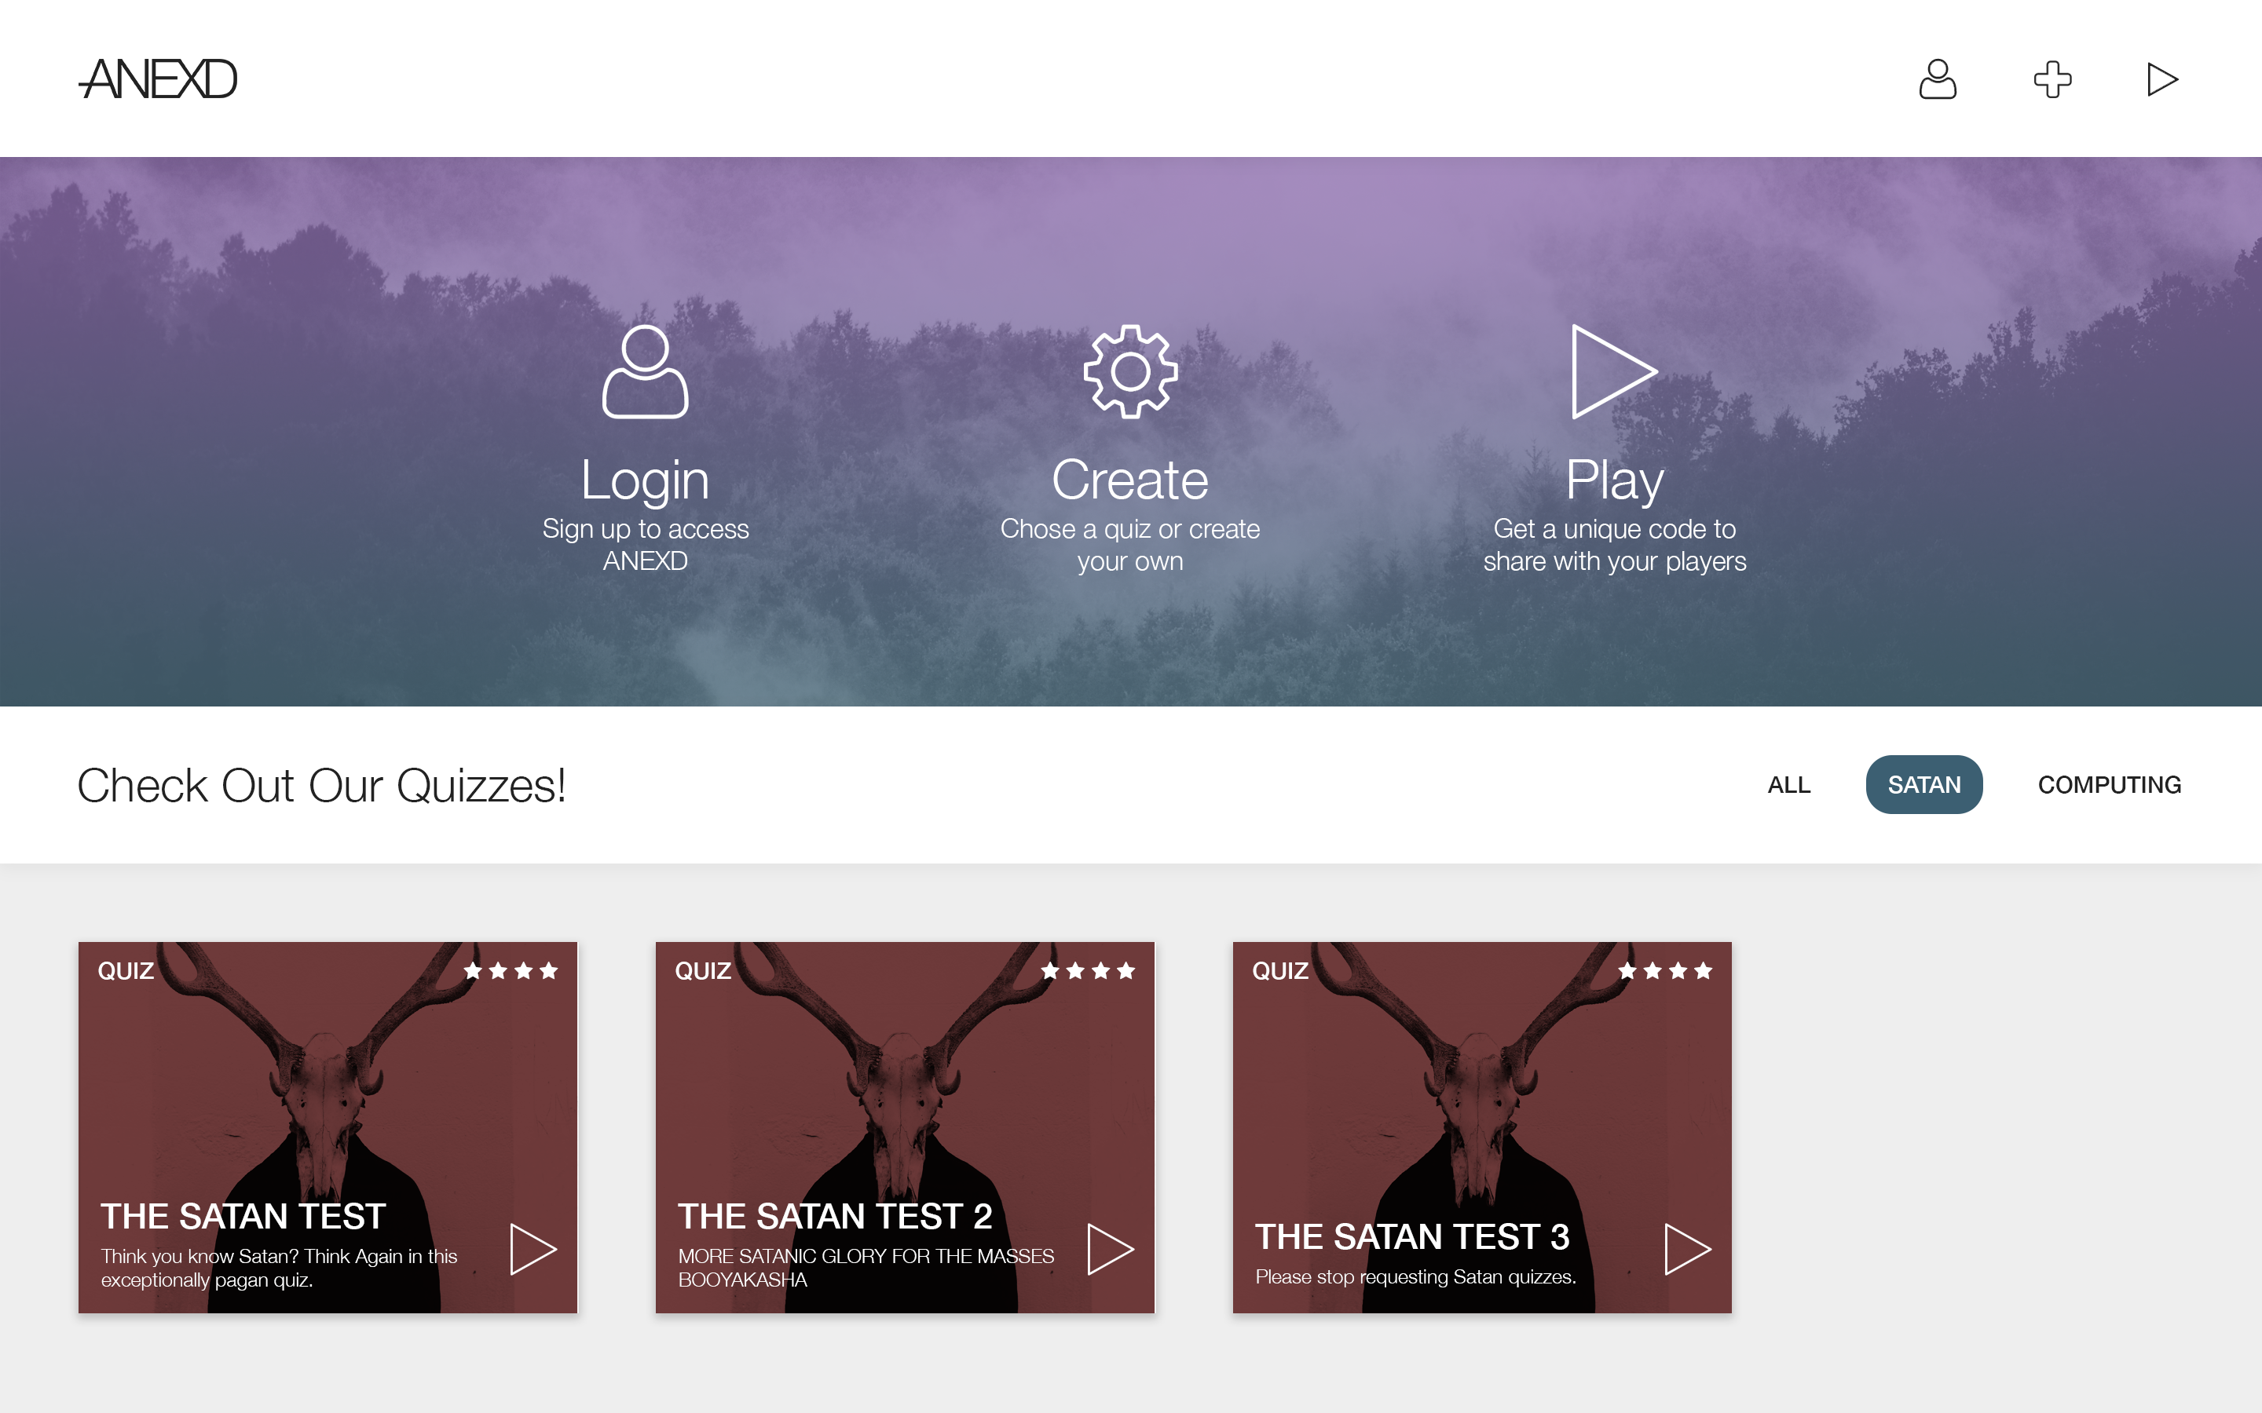

The home page came out clean and modern, focusing on high-resolution imagery and grey shades. Refined drop-shadows were used to produce depth in the design and show the hierarchy of the page.

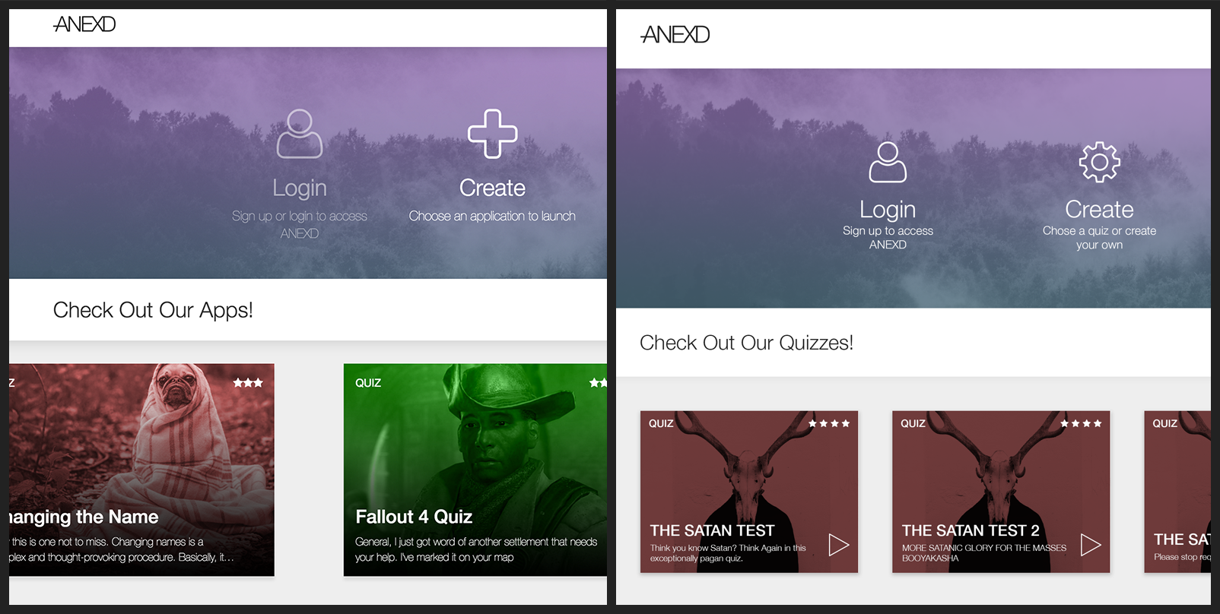

Here’s a comparison of how the final UI (left) and the original home design (right) differ. As you can see, we increased the size of the apps and reduced the top ‘steps’ section to allow for more room to display apps. Of course the copy also changed to support more than just quizzes.

### Desktop Sign in / Join

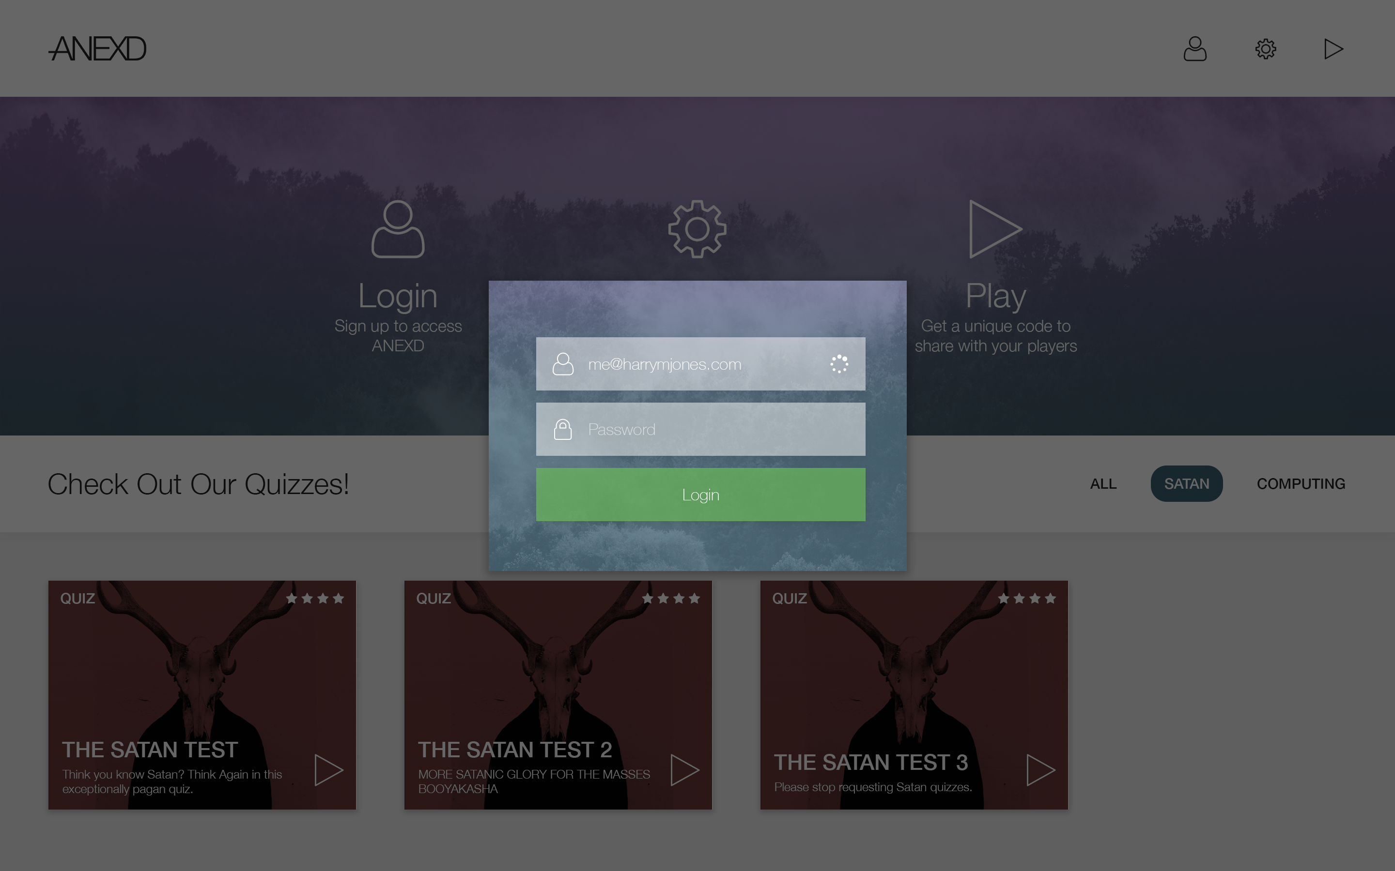

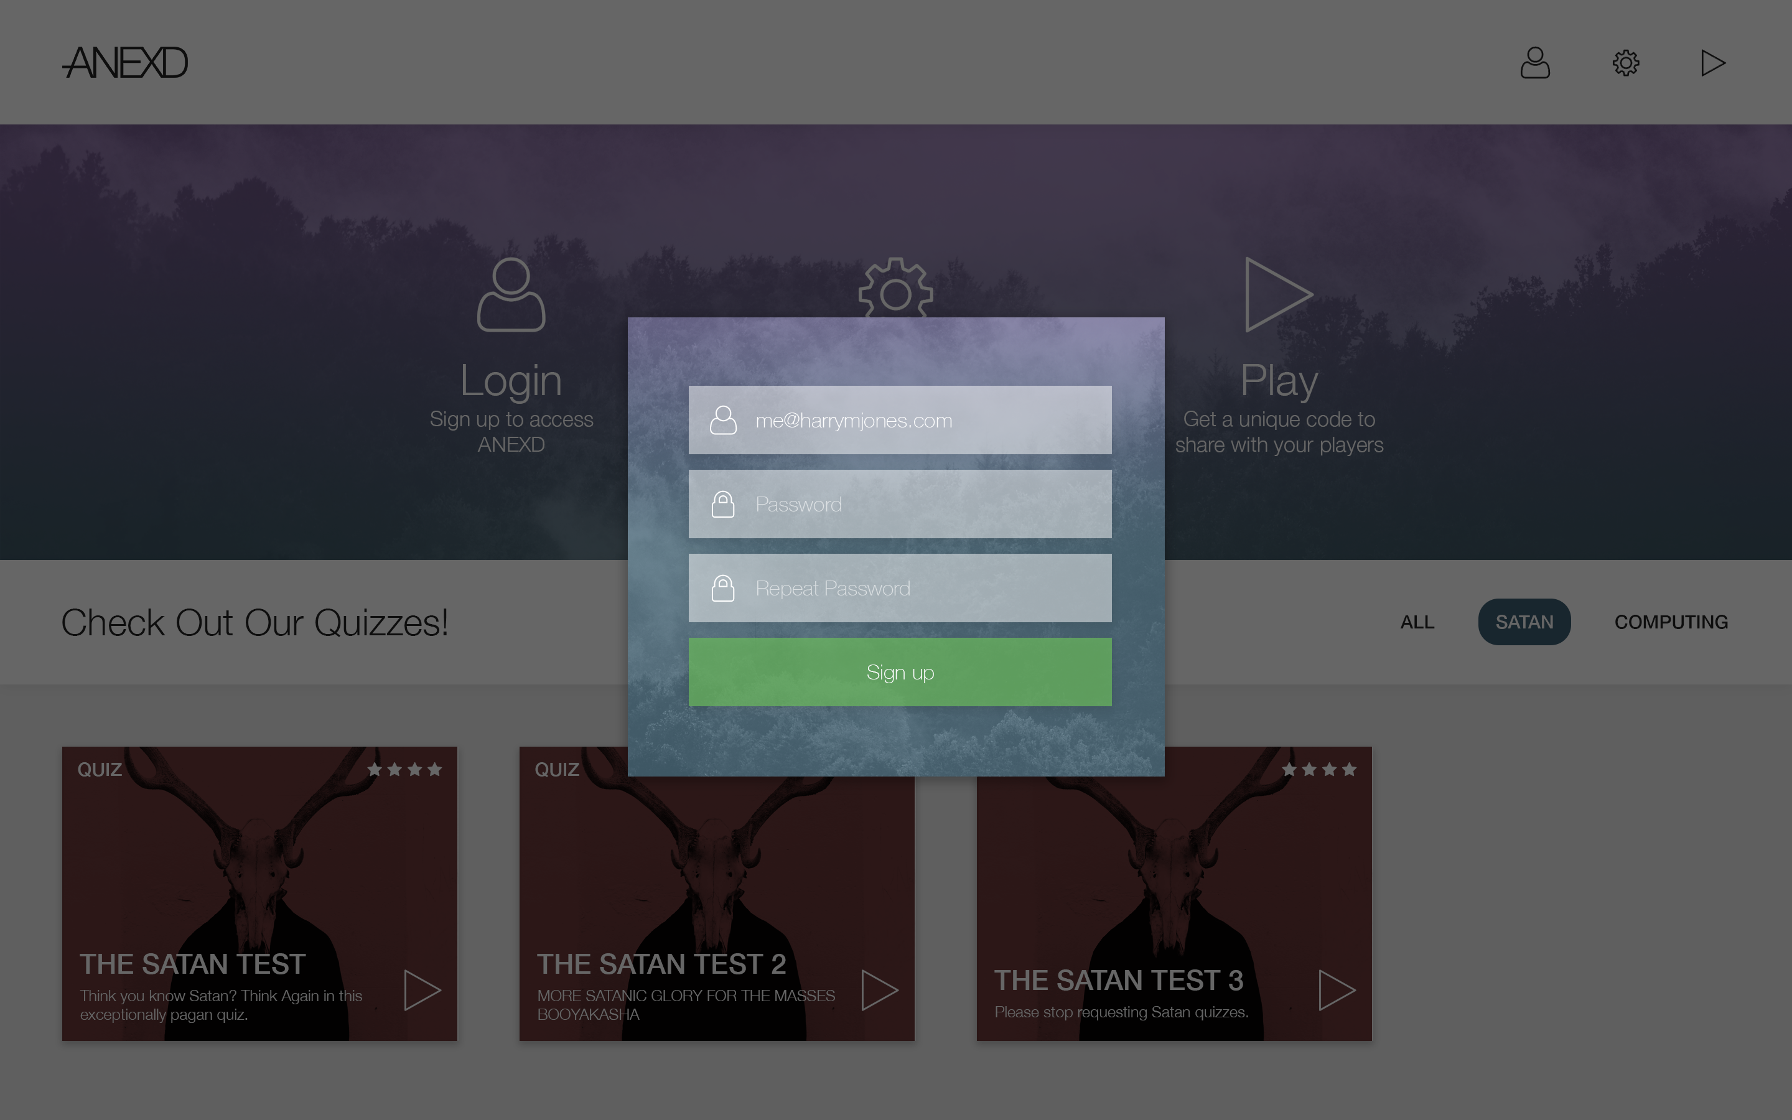

The designs for the login and sign up screens closely follow the storyboard. By placing them in a modal, we can allow users to log in and out without losing context of the page they are in. We can also easily call this modal from any part of the application, in the case of expired cookies or other session failures.

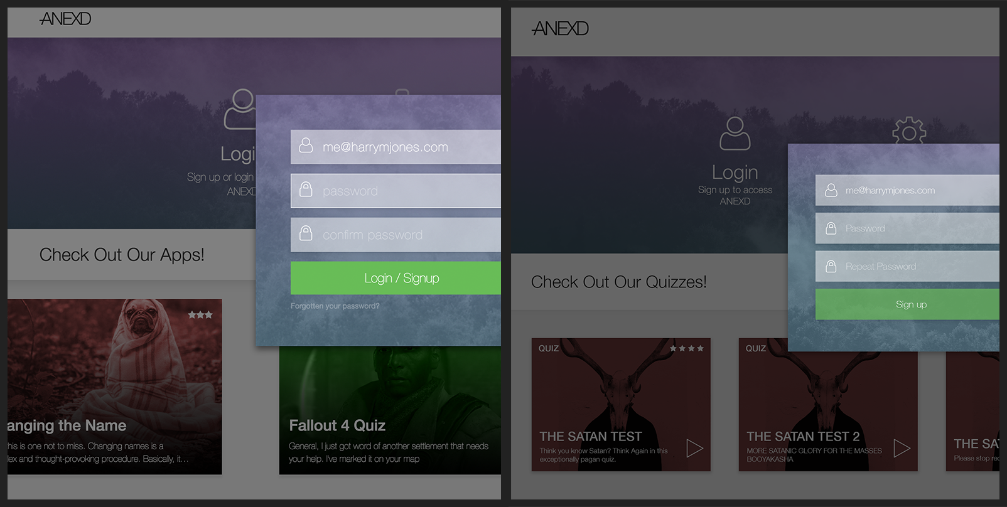

In the final UI, we increased the visibility massively. The low opacity and washed-out colours made it hard to read some of the fields, so by increasing the contrast we definitely improved the experience.

### Desktop Launch

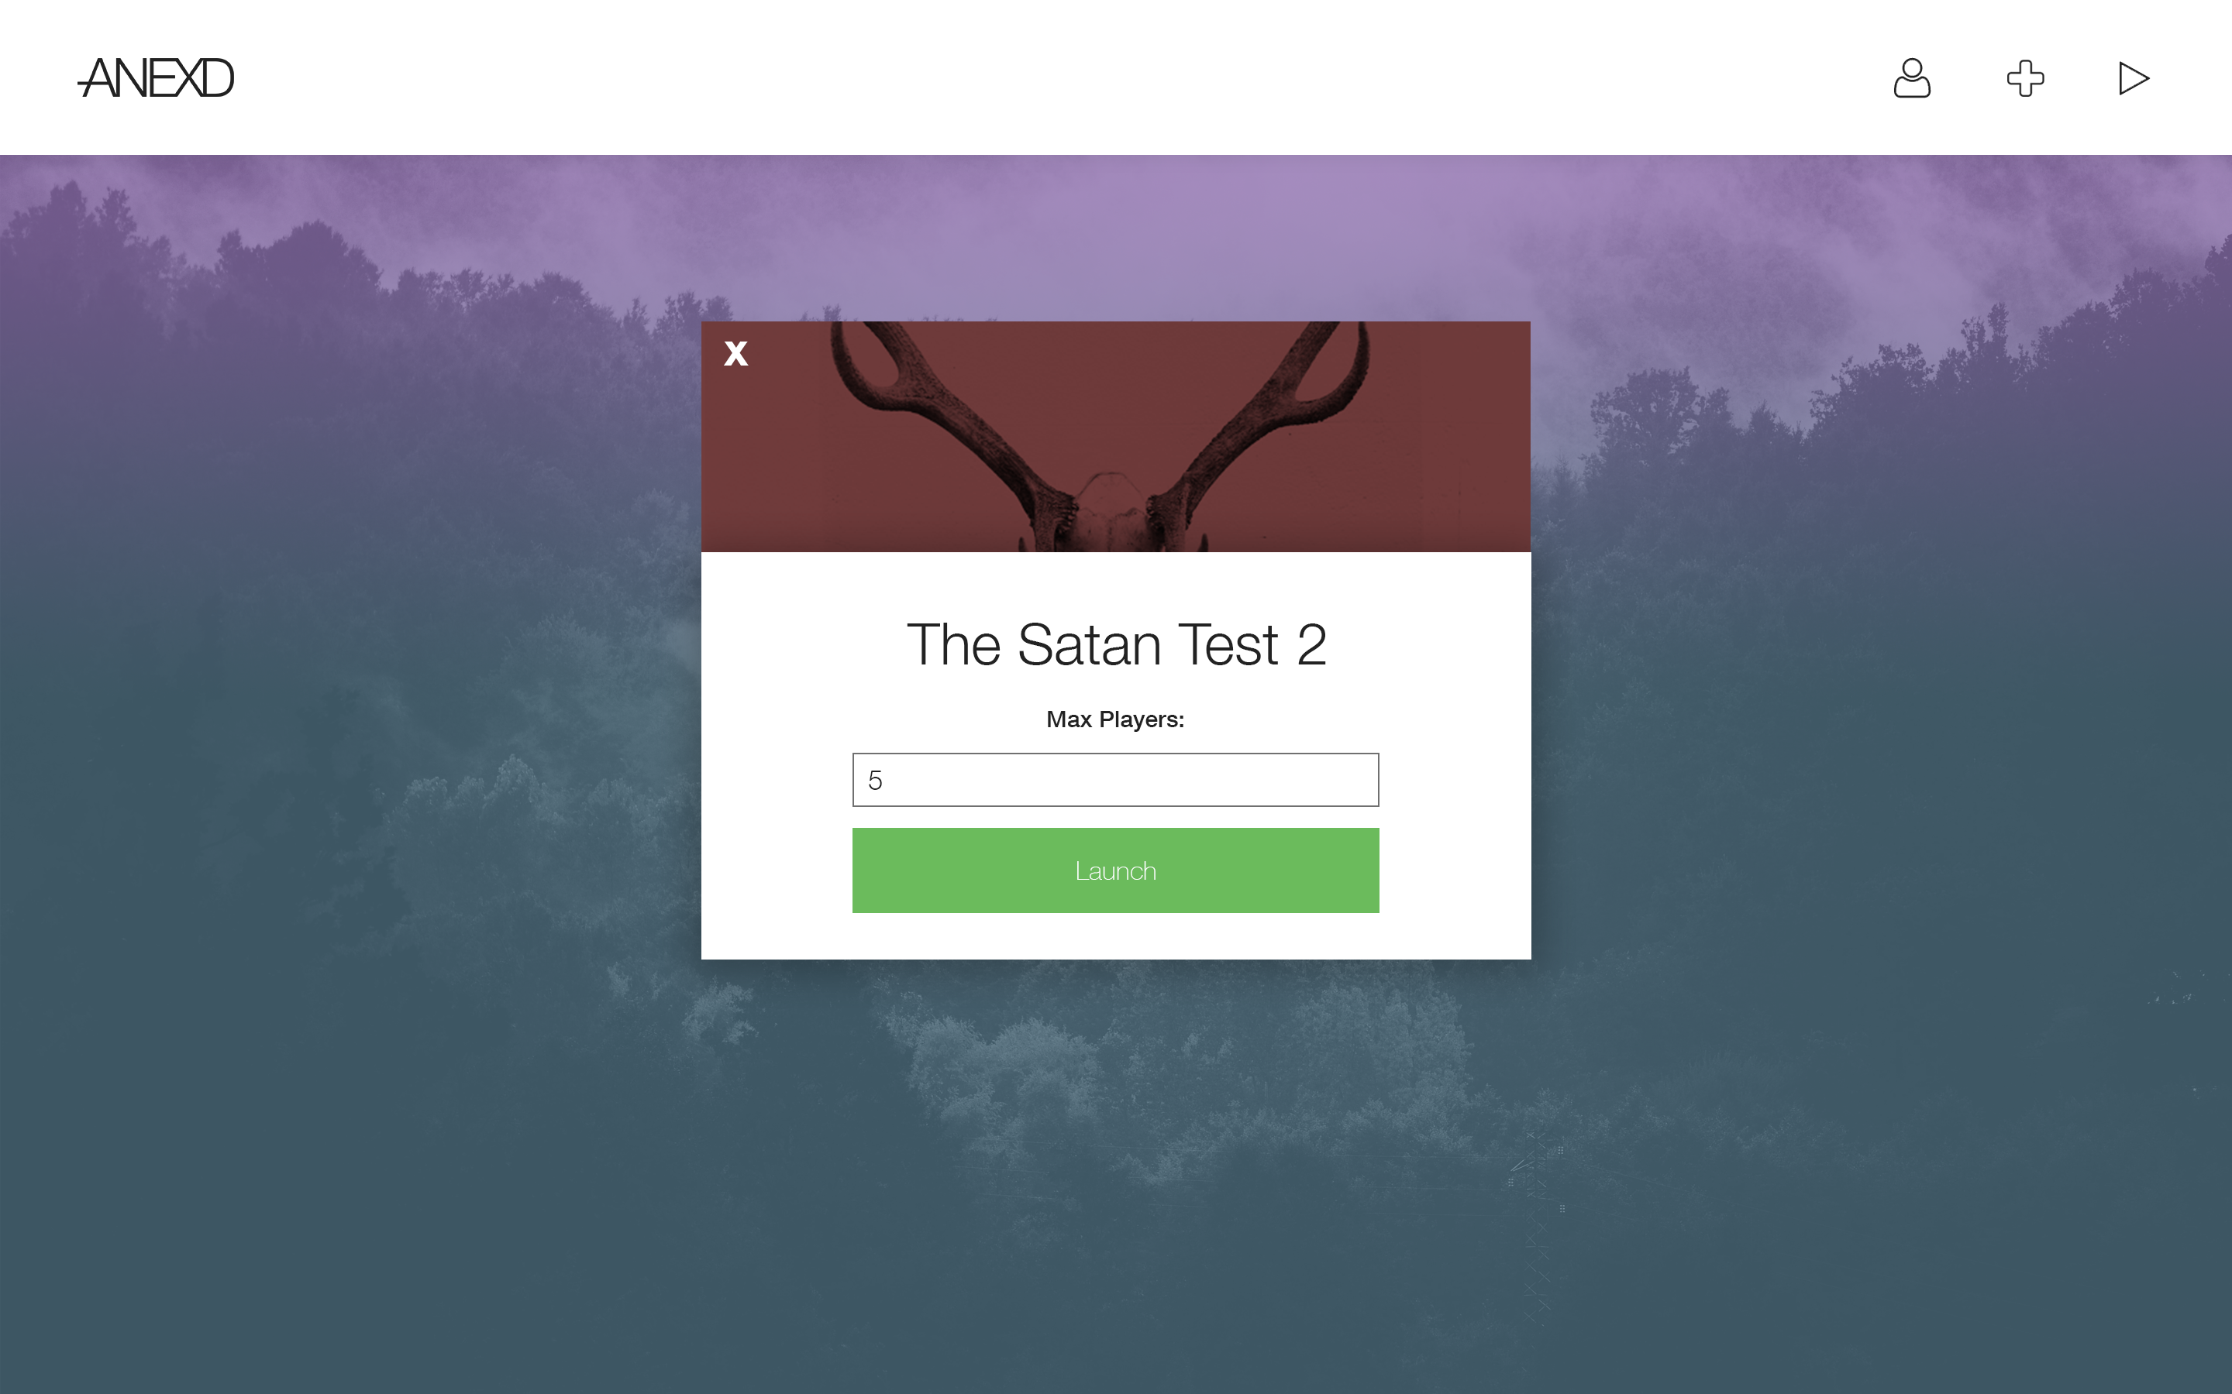

The launch screen was made to provide a clean and modern view of the application being loaded. By including the application’s image, we make it obvious which application will be loaded while also staying minimal.

One thing clearer in this screen is the presence of the three icons in the corner. These were removed from the UI as they no longer served a purpose, placing the user’s email in place instead.

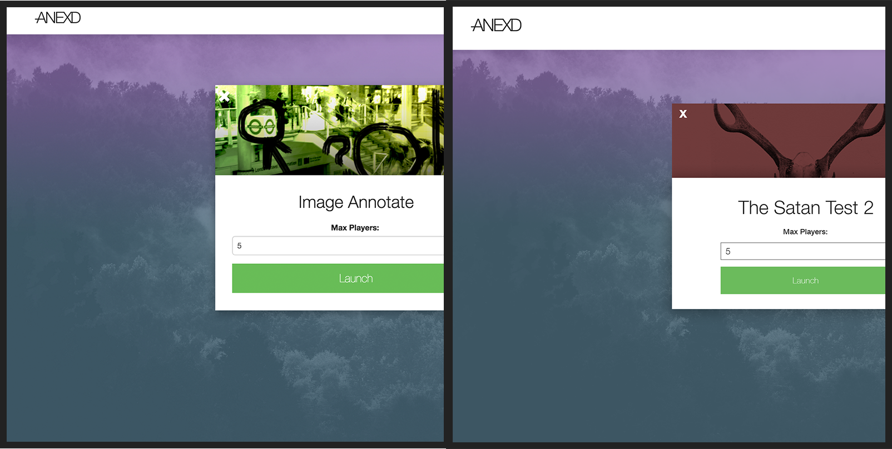

Virtually nothing changed in the transition from design (right) to UI (left). As a very simple view, there wasn’t much to change.

### Desktop Play

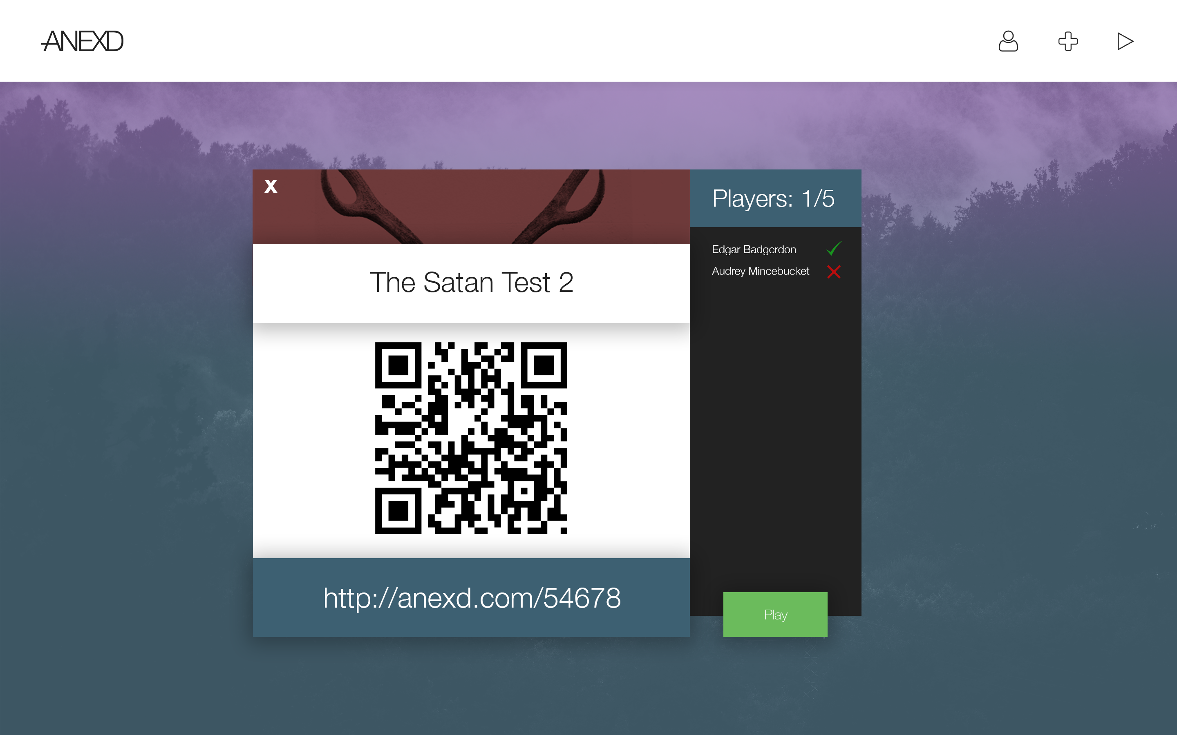

The ‘play’ screen extends from the ‘launch’ view above, adding in the QR code and also a URL to follow if the user would rather not use a QR reader. The lobby on the right was reduced in size against the storyboard to fit in better with the animations envisioned. The play button was moved to the bottom of the lobby as it is more related to the users than the lobby details that the left hand pane had become.

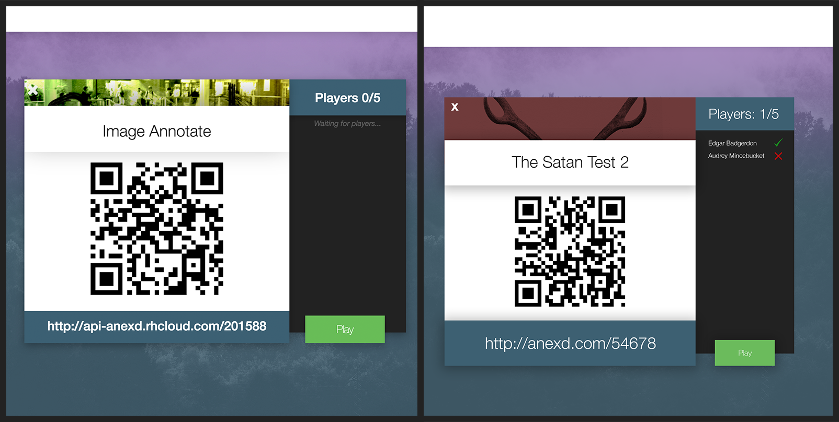

The only changes between the final UI (left) and the design (right) are in spacing, sizing, and font increases. These all come together to make the lobby much clearer and easier to use.

### Mobile Home

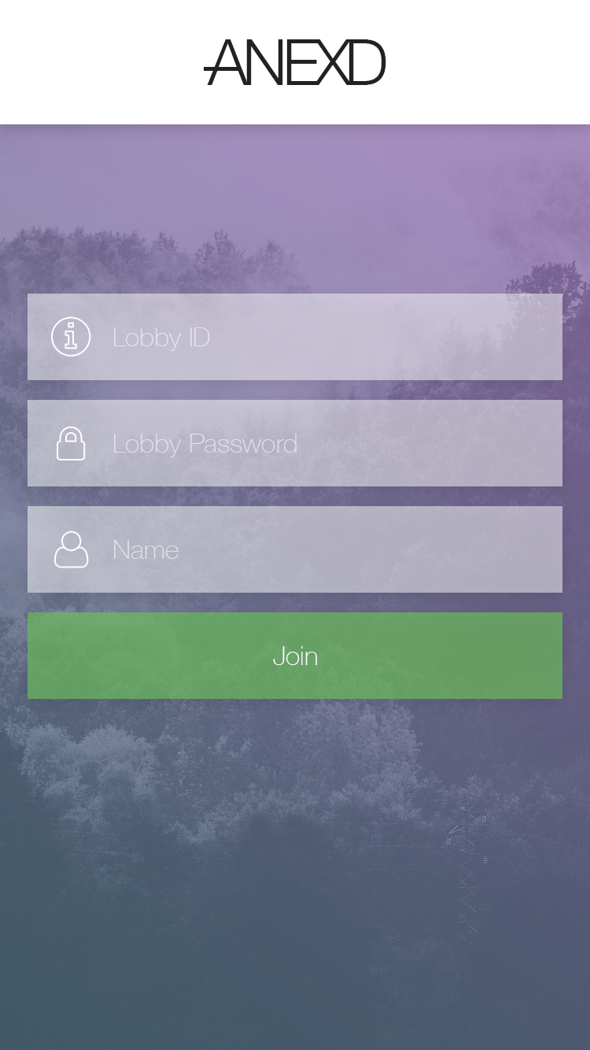

Mobile home shows three fields, but not exactly as seen on the storyboard. In this design, we have a lobby id, a lobby password and the user’s name. Emails were considered to be unnecessary as we couldn’t – and didn’t want to –validate them. They would essentially have been email-formatted nicknames.

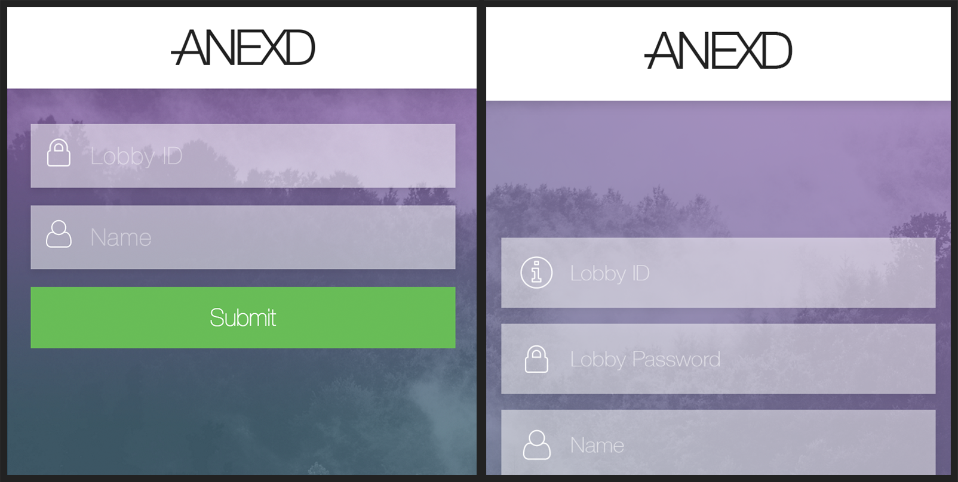

In the final UI, we removed ‘lobby password’ as it just became an extra step for the user that didn’t add any benefit. The two-field design is a leaner, and overall better experience for our mobile users. Again, lessons were learnt in the low contrast of the original design’s ‘submit’ button.

### Mobile Lobby

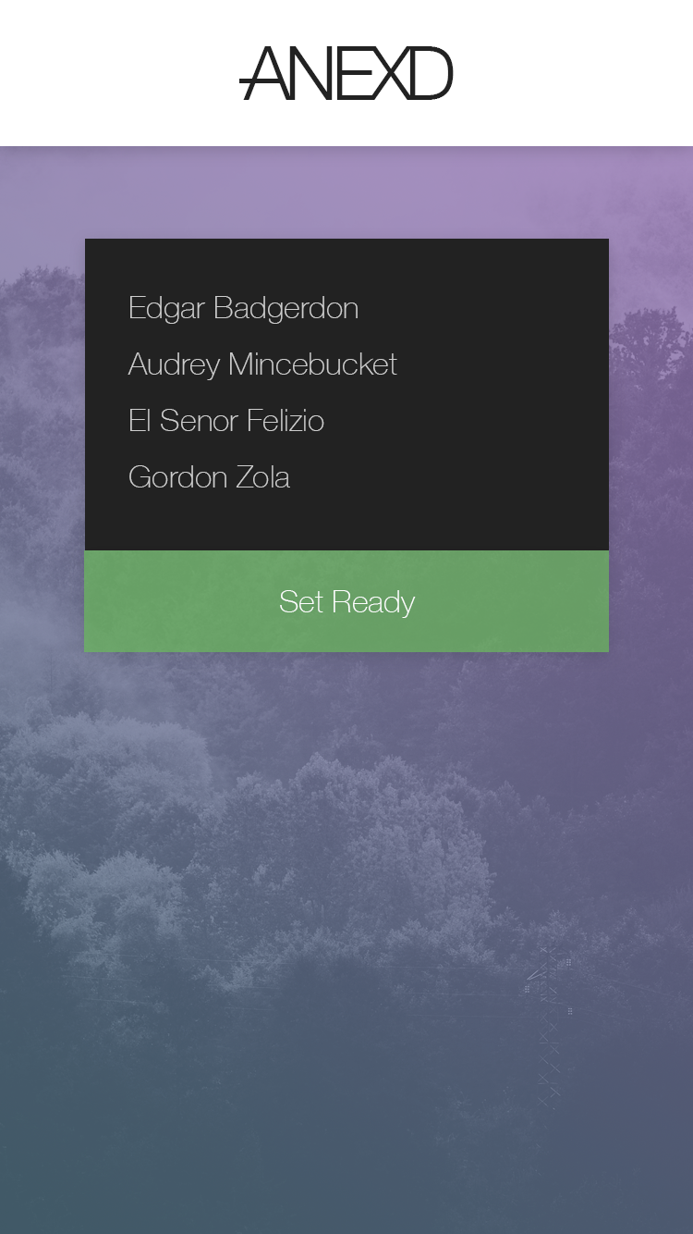

Mobile lobby ended up lacking a number of features that the UI required. These included a separate ‘back’ button to persist over applications, ready symbols, and more information about the lobby.

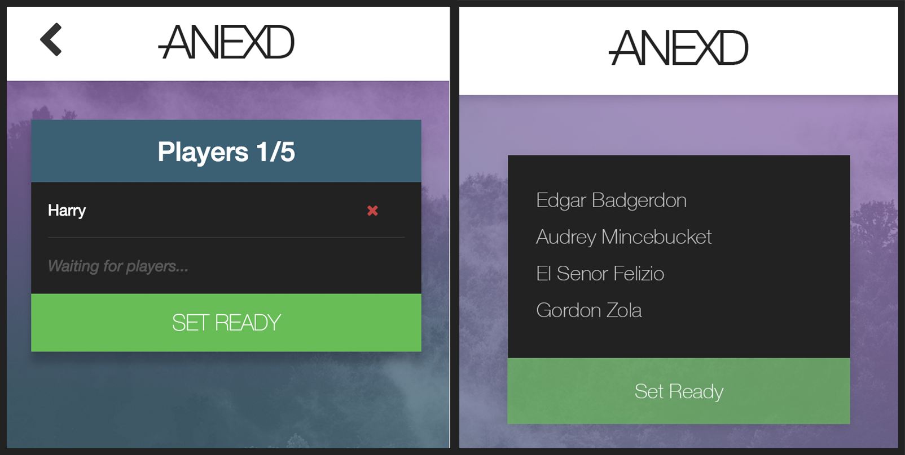

As you can see the final UI (left) came out far more refined that the initial design (right). We added the ‘ready’ icons and associated them against the background colour of the ‘SET READY’ button. A left-facing chevron was added to the top left corner to allow the user to return to the home page at any time.

# Conclusion

Over the course of the project, the UI has grown from basic ideas and hastily drawn diagrams to a fully-fledged design and polished user interface. The use of animations and our constant consideration for user requirements has allowed us to produce an experience that is fluid and modern, whilst still being minimal and clean.

In reflection, there’s little we would change about how the UX/UI has come out. By following our specifications, not much time was wasted on incomplete or incorrect designs, giving us much more time for finalising and improving the features we are providing to our users.